SHOE STORE MANAGEMENT - Shouseda Store

**1. Use case diagram**

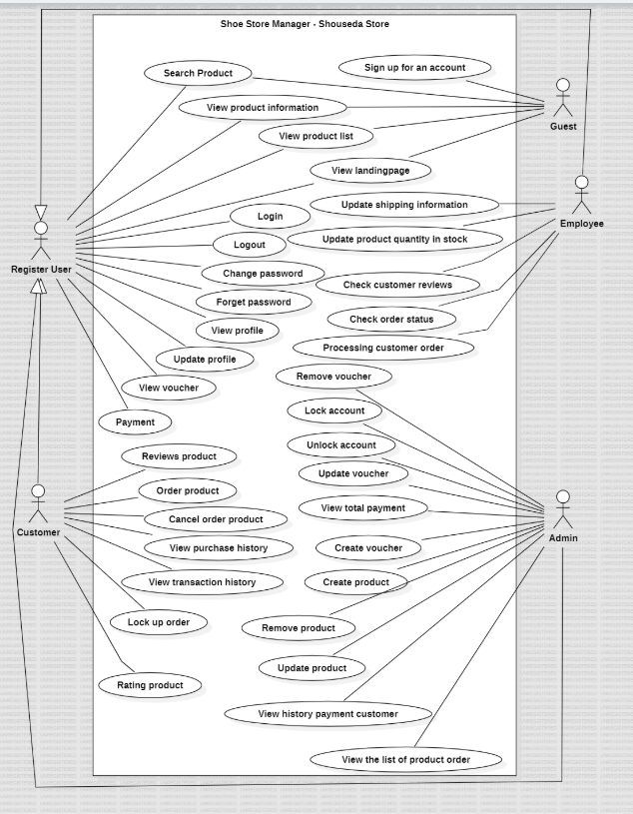

a.Use case - guest

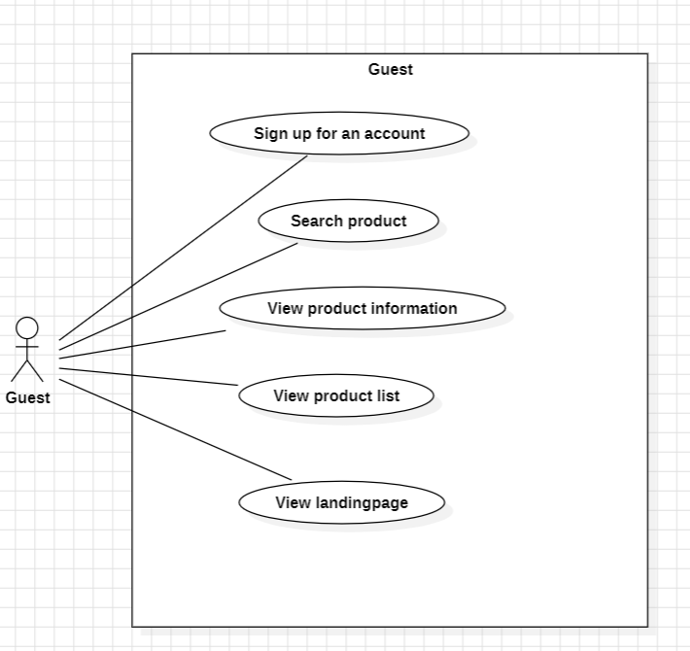

b.Use case - Customer

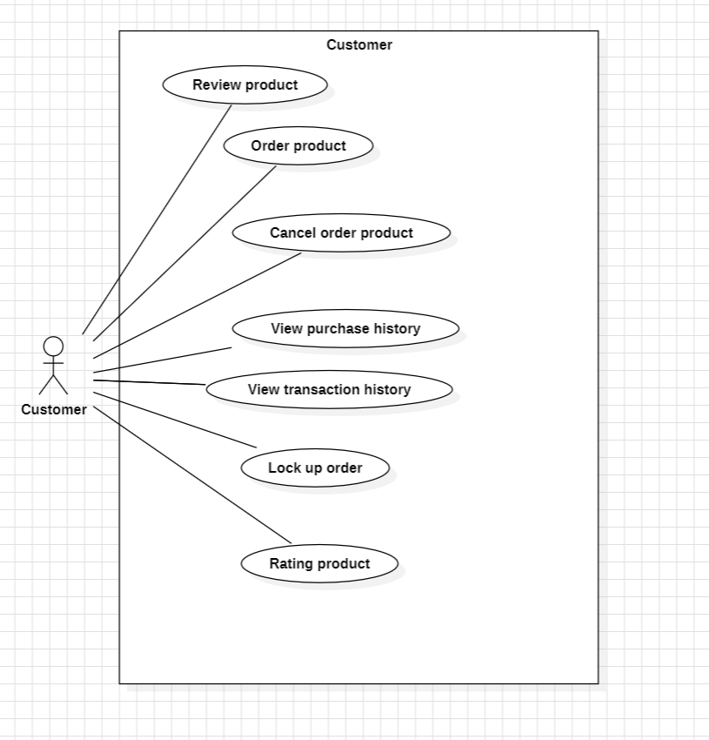

c.Use case - employee

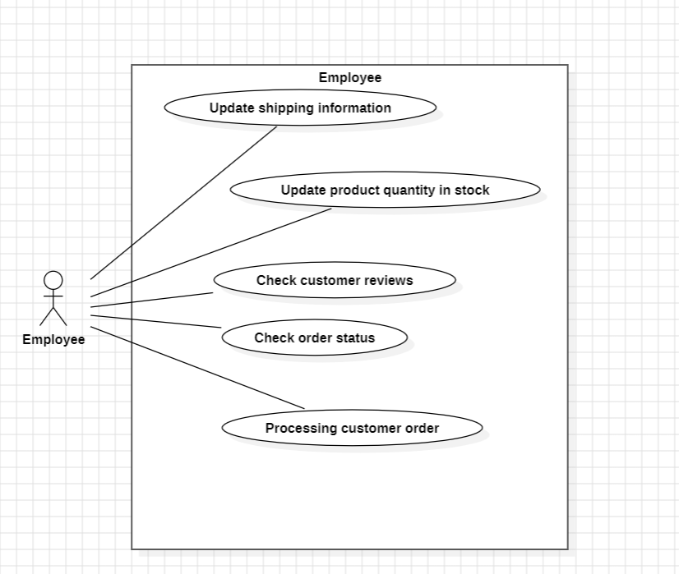

d.Use case - Admin

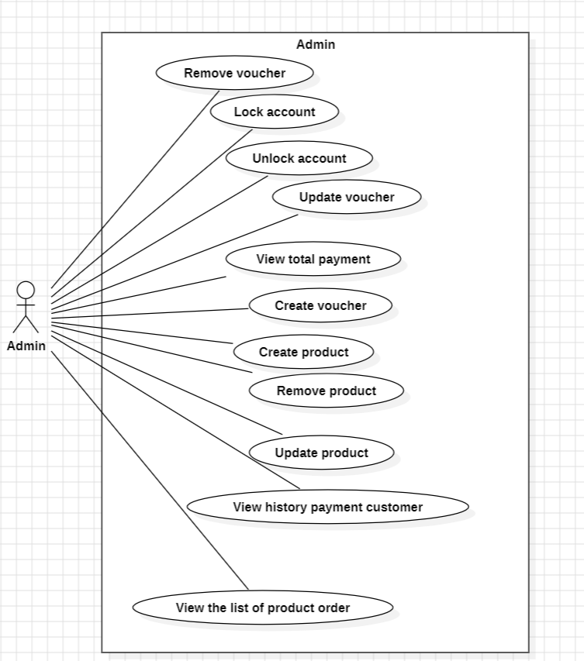

e . Register User ( customer - employee - admin)

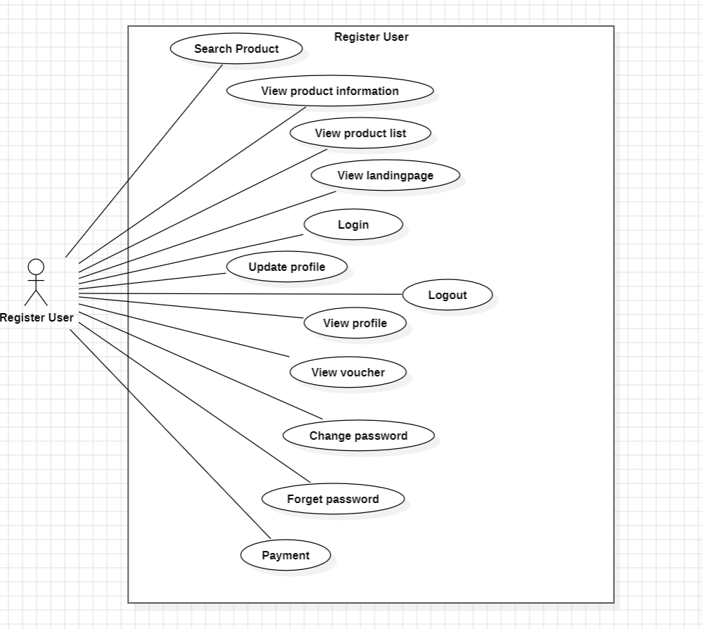

**2. Business rule**

***1. Guest (Non-logged-in visitors)***

*Search Product:*

Visitors can search for products by keyword (product name or category).

Results displayed only include products with the status "On Sale".

*View Product Information:*

Visitors can view product details (name, description, price, stock availability).

Cannot view "Out of Stock" or "Discontinued" products.

*View Product List:*

Visitors can browse the product list by category, price filter, or ranking order.

*View Landing Page:*

Landing page that displays featured or discounted products.

Visitors do not need to log in to view this content.

*Sign Up for an Account:*

Visitors can create an account with a valid email and password.

Accounts are only activated after email confirmation.

**2. Customer (Registered customers)**

*a. Account Management*

*Login:*

Users must enter the correct registered email and password.

After 5 incorrect logins, the account will be locked (needs Admin to unlock).

*Logout:*

Users can log out of the account at any time for security.

*Forget Password:*

Users can request a password reset via email.

The password recovery link is only valid for 24 hours.

*Update Profile:*

Users can update personal information such as name, phone number, and shipping address.

Email cannot be changed after registration.

*Change Password:*

Users must enter the correct old password to change to a new password.

*View Profile:*

Users can view basic personal information and account status.

*b. Interact with products*

*Order Product:*

Users can add products to the cart and make payment.

The system checks inventory quantity before confirming the order.

*Cancel Order Product:*

Users can cancel orders before the order status changes to "Shipping".

*View Purchase History:*

Displays a list of orders placed, including status and payment details.

*View Transaction History:*

Displays payment transactions (e.g. paid, pending confirmation).

*Review Product:*

Only customers who have purchased the product are allowed to write a review.

Each product can only be rated once.

*Rating Product:*

Customers can rate products on a scale of 1-5 stars.

Product ratings affect the order of display.

*Payment:*

Payment can be made via e-wallet, credit card, or bank transfer.

Payment is only successful if the system confirms the sufficient amount.

*c. Manage vouchers*

*View Voucher:*

Users can view available coupon codes (for products or total order value).

**3. Employee**

*Update Shipping Information:*

Update shipping status (e.g. Processing, In Delivery, Delivered).

"Cancelled" status cannot be edited.

*Update Product Quantity in Stock:*

Adjust product inventory based on new orders or stock.

*Check Order Status:*

Check order status based on order number.

Have the right to change order status except "Shipped".

Processing Customer Order:

Approve and process orders if payment is successful.

If payment fails, the order will be canceled.

*Check Customer Reviews:*

Can view customer reviews to improve service.

**4. Admin**

*a. User Management*

*Lock Account:*

Admin can lock accounts if policy violations are detected (e.g. voucher fraud).

*Unlock Account:*

Admin unlocks accounts when users demonstrate policy compliance.

*b. Manage Products*

*Create Product:*

Admin can add new products to the system (including name, price, description, image).

*Remove Product:*

Admin can delete products, but only if the product is no longer in the order being processed.

Update Product:

Admin can edit product information (e.g. price, description, image).

*c. Manage Vouchers*

*Create Voucher:*

Admin can create discount codes with conditions such as minimum order value.

*Update Voucher:*

Admin can edit the validity period or discount value of the voucher.

*Remove Voucher:*

Admin can delete the voucher if it is expired or invalid.

*d. Manage Orders*

*View Total Payment:*

Admin can view the total revenue of all orders for the day, week, or month.

*View History Payment Customer:*

Admin can view the payment history of each customer to verify transactions.

*View the List of Product Order:*

Display a list of ordered products for inventory management.